RECKLESS: A Memoir
Contact: Rebecca Allard
646.354.3326
E-mail info.recklessamemoir@gmail.com
Website www.recklessamemoir.net
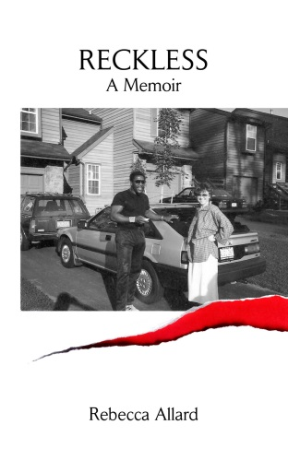
FOR IMMEDIATE RELEASE

“MOST OF US NEVER GET THIS CLOSE TO THE FLAME”

Why would a middle class white woman fall in love with a convicted felon from Harlem?

Rebecca Allard, Author of Reckless: A Memoir, shares her story of addiction to danger and the journey she took to reclaim her heart, mind and soul.

“Reckless reads like a psychologically-nuanced thriller, and is all the more riveting because of Rebecca Allard’s insistence on discovering her own responsibility in her near destruction. The intense push-pull of attraction to danger is beautifully rendered and devastating. Most of us never get this close to the flame.” - Philip Gerson is an award-winning playwright, screenwriter and television writer, whose credits include Murder, She Wrote and Dr. Quinn, Medicine Woman.

“Reckless is an intimate articulated psychological treatise of a woman who, in the vulnerability of her youth, fell in love with and married a psychopath.” - Catherine McCall, LMFT, and international bestselling author of Never Tell, A True Story of Overcoming a Terrifying Childhood.

Rebecca Allard began her professional acting career in 1971 and later became director of technology implementation for a Fortune 500 accounting and auditing firm. Her story begins in her Texas birthplace and unfolds in New York City in the ’70s and ’80s. Read more at www.recklessamemoir.net.
***
Visit www.recklessamemoir.net/press-kit for contact details, review copies, photos, and an author bio.

-ENDS-

